**VIDEO APPENDIX (comes from *New Cambridge English Course*)**

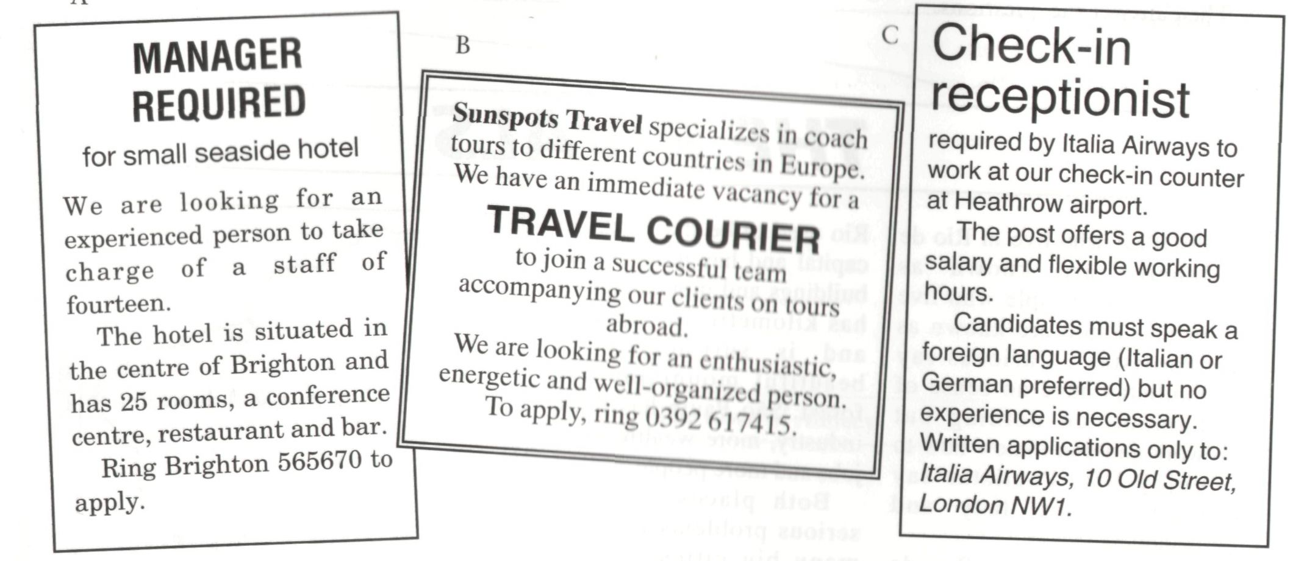**Look at the three job advertisements and answer the questions.**

1. Which jobs require experience?

* **Manager required**

1. Which jobs require foreign languages?

**- Italia Airways**

1. For which jobs do you need to travel?

* **Sunspots Travel**

1. Which job has the most responsibility?

**These two people are looking for a new job**

**Which of the three jobs do you think they should apply for?**

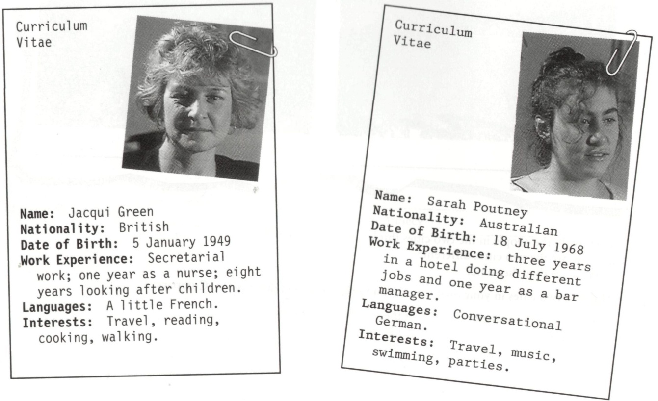

**Watch the video all the way through. Which of the three jobs in Task A are Sarah and Jacqui being interviewed for?**

**Watch the section 'Before the interview' and choose suitable words from the vocabulary box to complete the sentences.**

1. a) At the interview, Jacqui wants to look……………………. .

b) At the interview, Sarah wants to look……………………. .

2. a) Jacqui seems to be a(n)…………..person.

b) Sarah seems to be a(n)…………...person.

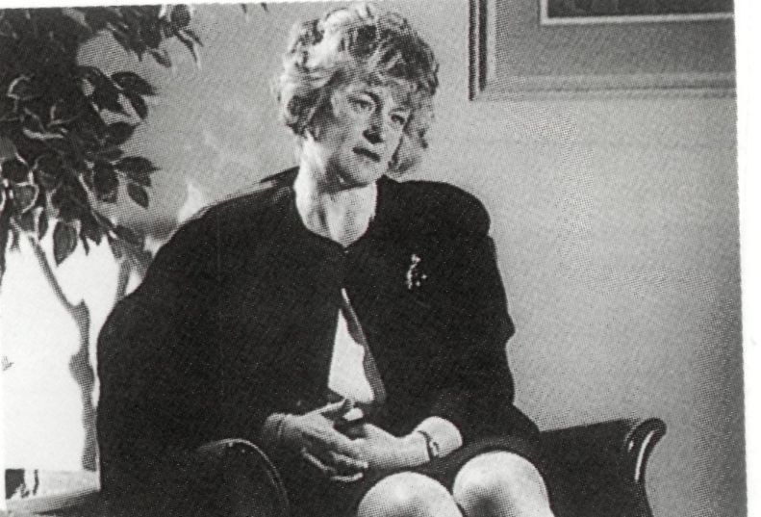*shy relaxed*

*experienced anxious*

*aggressive inexperienced*

*calm confident*

*professional friendly*

*ambitious intelligent*

**Watch the section 'Present jobs'. Then fill in the missing names in the sentences.**

1 ………………….has recently arrived in Britain.

2…………………..working for a newspaper.

3…………………..looking for a job with long-term prospects.

4…………………..doing anything that comes along.

**Watch the section 'Past experience'. *'True'* or *'False'***

1. Sarah spent three years working in a hotel.
2. Jacqui worked as a child-minder when she was eighteen.
3. Sarah found the tourists at the hotel difficult.
4. Sarah has worked as a hospital nurse.
5. Jacqui has worked with people of different ages.
6. Both of them have secretarial experience.

**Look at the countries and languages in the box. As you watch the section “Travel and languages”, note down which countries Sarah and Jacqui have visited and what languages they can speak. Write *“J”* for Jacqui and “S”for Sarah.**

**Countries visited**

Spain ( ) ( ) Denmark ( ) ( ) Italy ( ) ( )

France ( ) ( ) Portugal ( ) ( ) Germany ( ) ( )

Sweden ( ) ( ) Egypt ( ) ( ) Canada ( ) ( )

Mexico ( ) ( ) Thailand ( ) ( ) Indonesia ( ) ( )

**Languages spoken**

French ( ) ( ) German ( ) ( ) Spanish ( ) ( )

**Watch the fifth section, 'Reasons for applying', and fill in the missing information.**

1. Jacqui enjoys t………………
2. Sarah likes the idea of w………….with t……………
3. Jacqui believes she has certain s………..that will benefit the c…………
4. Sarah thinks the idea of travelling is e……………

**Watch the video all the way through again. Fill in the table with your comments and decide whether Jacqui and Sarah are suitable candidates for the vacant job.**

|  |  |  |
| --- | --- | --- |
|  | Jacqui Green | Sarah Poutney |
| Appearance |  |  |
| Personality |  |  |
| Experience |  |  |
| Travel and languages |  |  |
| Overall impression |  |  |

**Discuss with a partner who impressed you most in the interview and who, in your opinion, should get the job.**

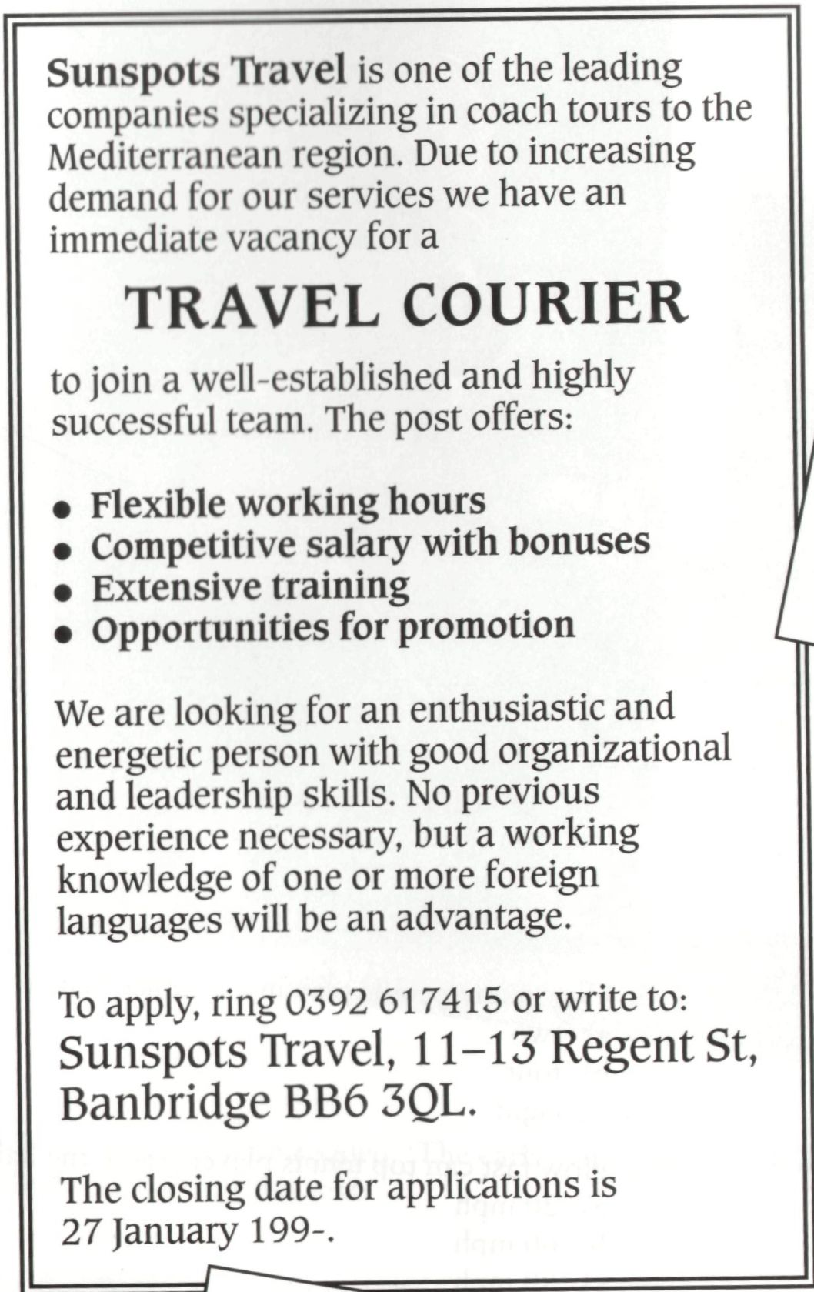**Work in pairs. One person should be the interviewee and the other the interviewer.**

